ICT Project
Phase 1
- Idea and Name:
The idea for our website is it will be a Coaching Centre and the name of the website will be Visionize.
- Group Members:
Jawad Mansoor - 232414
Ali Asghar - 232411
- Introduction:
The purpose of this website is to provide online classes and services to students that are struggling with certain subjects in their University, School etc. Visionize will aim to help these students exceed their limit and become the best at that certain subject.
- Objectives:
1-Quality Education
2-To help students clear their concepts
3-Betterment of youth
4-Better Use of Time
- Specifications:
1-Html (Hypertext Markup Language)
2-Css (Cascade Style Sheet)
3-Java (Front End)
4-Figma (UI Design)
- Timeline:
1-Week 1:
Planning Phase – Planning everything and designing everything through figma.
2-Week 2:
Working Phase – Working on every category and every page of the website and implementing every feature.
3- Week 3:
Fixing Phase – This is the phase where we will fix all the bugs and do all the repairs on the website.
- Layout and Figma:
1-Log-in Page:
The login page will be the first page and will ask the user for their username and password but this is only for second time visitors or old visitors.
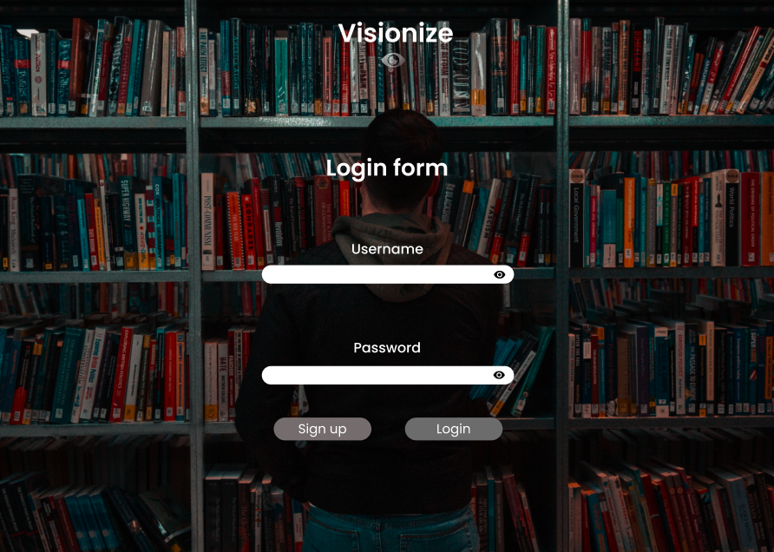
2-Sign-up Page:
The second page will be the Sign-up page it will ask new users or first-time users to sign up in order to access the website.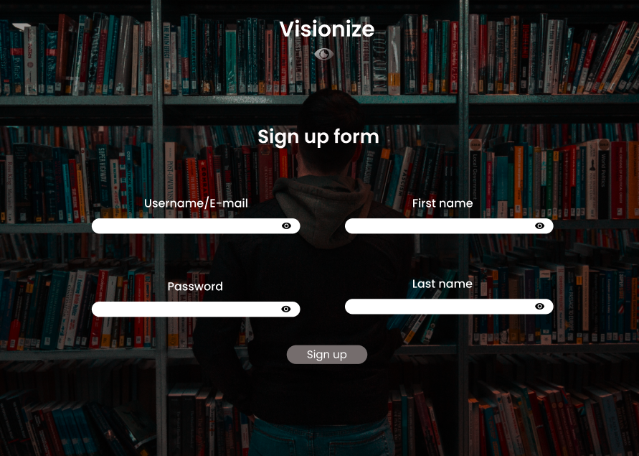
3-About Us:
The third page will be the about us page which will give us a brief introduction about our website and our coaching staff and way to contact them.
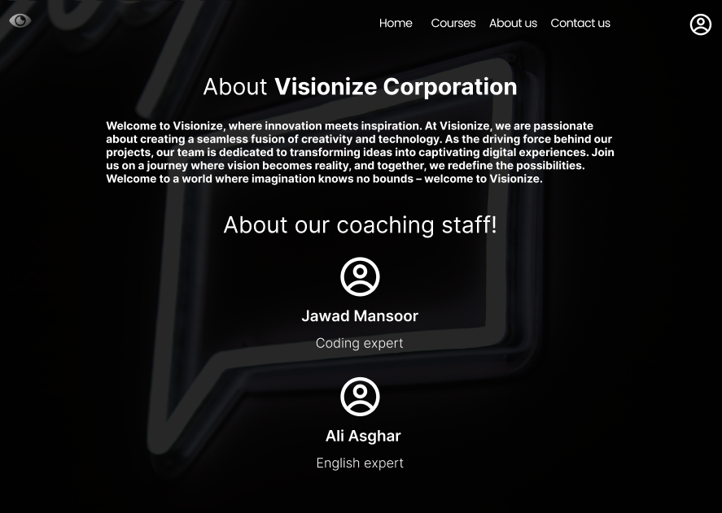
4-Home Page:
The next page will be the home page which will tell a littler intro about the website and give a little walkthrough the entire website.
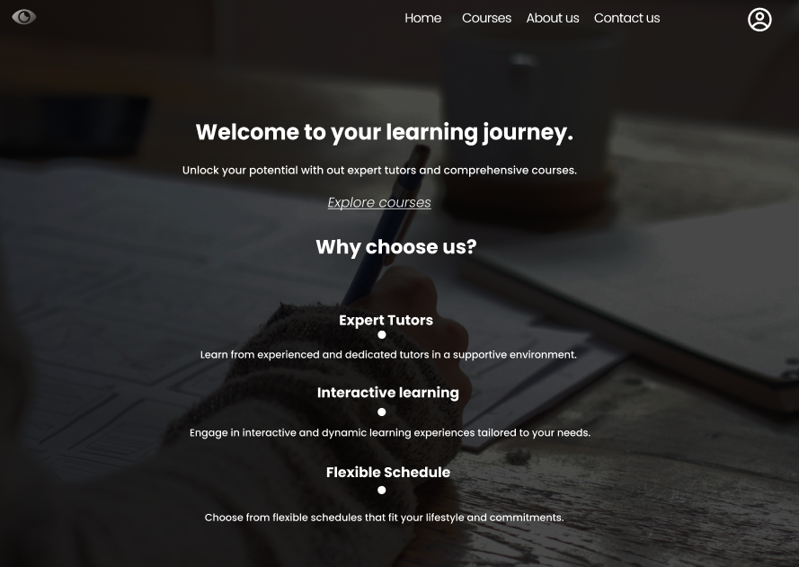
5-Courses:
The next page will be the courses page in which we will offer different courses for our students and they can pick from an available set of subjects.

6-Contact Us:
Now the next page will be the contact us page through which the students can contact us if they have any issues in our website and teachers.
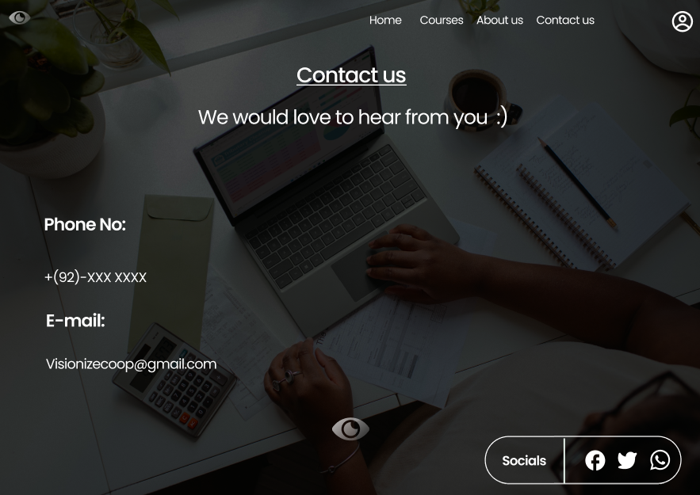

Conclusion:
We will try our best to completely code the website according to the design and add more features down the line. Thankyou!!

